ISTM-622 PROJECT GIGAVOLT MILESTONE 2

SQL Programming, RAG Payload Preparation & Audit Security

~ Atharva Kedar

TABLE OF CONTENTS
CONTENT | PAGE_NO
1. Overview & YouTube Video Link | 1
2. Objectives | 2
3. Milestone 1 Foundation | 3
4. Generated / Virtual Columns for RAG Context | 4
5. RAG Payload Table | 5
6. Stored Procedure: sp_Prepare_RAG_Payloads() | 6
7. Audit Log Table | 7
8. Audit Trigger Implementation | 8
9. Security Views | 9
10. VALIDATION QUERIES & Sample Output | 11
11. Design Decisions & Rationale | 12
12. Code Artifacts | 12
13. 4Ds of AI Fluency | 13
14. Final Summary | 13
15. Complete Code | 14

1. Overview & YouTube Video Link
Milestone 2 builds on the normalized MariaDB database created in Milestone 1. In Milestone 1, the raw Gigavolt ERP data was ingested into staging tables, cleaned, transformed, and loaded into normalized production tables. The production database contains cleaned tables for customers, equipment, dispatch/service records, parts, warranty claims, and locations.
Milestone 2 focuses on SQL programming features that support downstream AI/RAG processing and audit compliance. The main additions are generated columns, a stored procedure to prepare RAG payloads, audit triggers, an immutable audit log table, and security views.
The project instructions require Milestone 2 to include generated columns for RAG payload consumption, a stored procedure named similar to sp_Prepare_RAG_Payloads(), audit triggers for INSERT and UPDATE operations, an immutable Audit_Logs table, and security views or policies to restrict sensitive customer information.
YouTube Video Link: ISTM 622 Milestone 2 Demonstration Link
Github code repo link: Github Repo Link
2. Objectives

The objective of Milestone 2 is to build programmatic SQL constructs that automate data preparation for downstream AI consumption and enforce audit compliance.

Objective | Implementation
Create generated / virtual columns | Added context columns to dispatches, equipment, and warranty_claims
Prepare data for RAG | Created rag_payloads table
Build stored procedure | Created sp_Prepare_RAG_Payloads()
Implement audit logging | Created audit_logs table
Add triggers | Added AFTER INSERT and BEFORE UPDATE triggers
Protect sensitive data | Created vw_customer_safe and vw_warranty_claims_safe
Validate functionality | Ran procedure, trigger tests, audit log checks, and security view queries

3. Milestone 1 Foundation

Milestone 1 created the relational foundation for the project. The raw ERP files were loaded into staging tables and then transformed into production tables. The cleaned production layer uses typed columns, primary keys, foreign keys, and InnoDB tables for relational integrity.
The main production tables used in Milestone 2 are:

Table | Purpose
customers | Customer master information
equipment | Equipment installed for customers
dispatches | Technician dispatch and service records
parts | Parts catalog and inventory data
warranty_claims | Warranty claim records
locations | Normalized ZIP/city/state/country reference data
Milestone 1 handled relational data cleaning such as standardizing dates, removing HTML tags, handling duplicates, formatting phone values, and enforcing foreign key relationships. Milestone 2 builds on that cleaned data and prepares it for future AI and RAG usage.

4. Generated / Virtual Columns for RAG Context

A generated column is a column whose value is automatically calculated from other columns in the same row. In this milestone, generated columns were used to create readable text context from structured database fields.
Generated columns are useful for RAG because RAG systems work better with natural-language-style text than with separate database columns. Instead of only storing separate fields like technician, service type, and resolution summary, the generated column combines them into one readable service context.
The Milestone 2 requirement specifically asks for virtual/generated columns that dynamically concatenate operational metadata for RAG payload consumption.
The generated columns created are:

Table | Generated Column | Purpose
dispatches | service_context | Combines dispatch/service fields
equipment | equipment_context | Combines equipment metadata
warranty_claims | warranty_context | Combines warranty claim details

VALIDATION QUERIES:
SHOW COLUMNS FROM dispatches LIKE 'service_context';
SHOW COLUMNS FROM equipment LIKE 'equipment_context';
SHOW COLUMNS FROM warranty_claims LIKE 'warranty_context';
SAMPLE OUTPUTS:

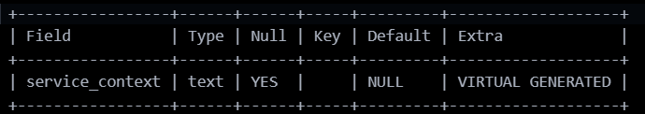

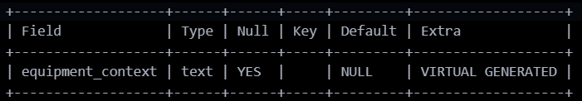

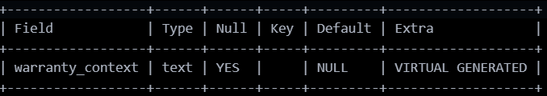

5. RAG Payload Table

The rag_payloads table stores final RAG-ready text blocks. These text blocks are not embeddings yet. They are prepared text payloads that can later be sent to an embedding model and stored in a vector database.
This is important because later milestones will involve text chunking, embedding generation, vector search, and RAG retrieval. Milestone 4, for example, requires chunking technical documents and service records into searchable embeddings. Milestone 2 prepares the relational data for that future step.
The rag_payloads table includes:

Column | Purpose
rag_payload_id | Unique ID for each payload
source_type | Type of payload, such as service log or warranty claim
source_id | Original source record ID
equipment_id | Related equipment ID
customer_id | Related customer ID
rag_text | Final RAG-ready text
created_at | Timestamp when payload was created
Example payload types:
- EQUIPMENT_PROFILE
- DISPATCH_SERVICE_LOG
- WARRANTY_CLAIM

6. Stored Procedure: sp_Prepare_RAG_Payloads()

The stored procedure created for this milestone is: sp_Prepare_RAG_Payloads()
The procedure reads from the production tables, joins related data, formats the records into readable text, and inserts the results into the rag_payloads table.
The procedure uses INSERT INTO ... SELECT statements. This means it does not insert one manual row at a time. Instead, it selects many records from the production tables and inserts many RAG payload rows at once.
The procedure performs the following steps:
- Clears old RAG payloads using TRUNCATE TABLE rag_payloads.
- Creates equipment profile payloads.
- Creates dispatch/service log payloads.
- Creates warranty claim payloads.
- Cleans text using TRIM() and REGEXP_REPLACE().
- Handles missing values using IFNULL().
Example procedure call:
CALL sp_Prepare_RAG_Payloads();
VALIDATION QUERIES:
SELECT
source_type,
COUNT(*) AS payload_count
FROM rag_payloads
GROUP BY source_type;
SAMPLE OUTPUT:
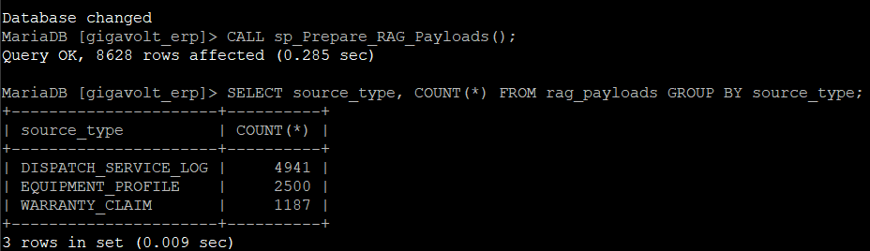

7. Audit Log Table

Milestone 2 requires an immutable audit log table that captures timestamp, user, table name, operation type, old values, new values, and change details.
The audit table created is: audit_logs

Column | Purpose
audit_id | Unique audit event ID
table_name | Name of the table that changed
operation_type | Operation such as INSERT or UPDATE
record_id | Primary key of the changed record
old_values | JSON object containing old values
new_values | JSON object containing new values
changed_by | Database user who made the change
changed_at | Timestamp of the change
change_description | Human-readable description
This table provides a complete change history for important production data.

8. Audit Trigger Implementation

Triggers are automatic SQL actions that run when something happens to a table. For Milestone 2, I implemented two main types of triggers:

Trigger Type | Purpose
AFTER INSERT | Records new rows after they are created
BEFORE UPDATE | Records old and new values before a row is changed

The project instructions specifically require BEFORE UPDATE triggers to log pre-change values and AFTER INSERT triggers to track new record creation.
Triggers were added for the following production tables:
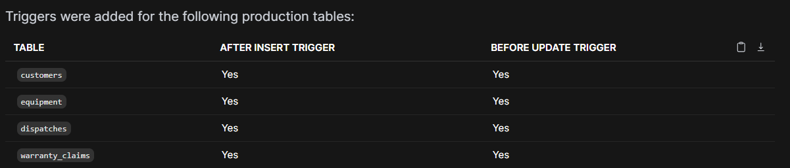

Trigger Logic
- For an insert: New row is inserted → AFTER INSERT trigger fires → Trigger writes new row details to audit_logs.
- For an update: Existing row is about to change → BEFORE UPDATE trigger fires → Trigger captures OLD values and NEW values → Trigger writes change details to audit_logs.
- The triggers use MariaDB’s OLD and NEW row references. (e.g., OLD.status means the value before the update, NEW.status means the value after the update.)

9. Security Views

Milestone 2 requires views or row-level security policies to restrict access to sensitive customer information.
I implemented two security views:

View | Purpose
vw_customer_safe | Masks customer phone and email information
vw_warranty_claims_safe | Redacts warranty financial and claim details
9.1 Customer Security View
The customer security view hides sensitive customer information. Instead of exposing the full customers table, users can query vw_customer_safe. This view shows masked values such as ***-***-4144 and bi***@innovativevolt.com. The view does not expose full customer phone numbers, emails, or street addresses.
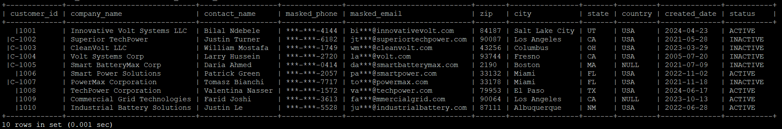
9.2 Warranty Claims Security View
The warranty security view hides sensitive financial and claim details. This security view allows users to see operational claim status while protecting sensitive financial and claim-note details.
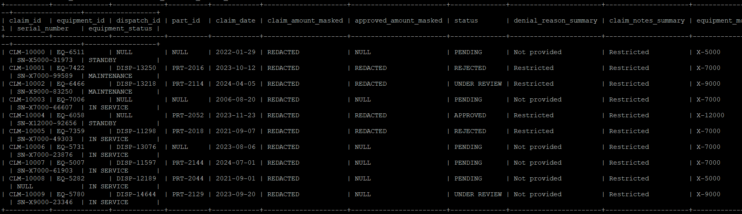

10. VALIDATION QUERIES & Sample Output
- 10.1 Show Tables: SHOW TABLES; confirmed that the Milestone 2 tables and views were successfully created.

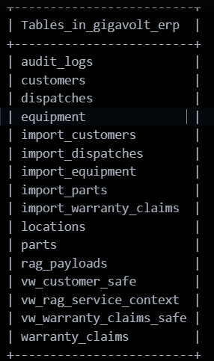

- 10.2 RAG Payload Count: Querying rag_payloads confirmed that the stored procedure generated RAG-ready payloads from dispatch/service logs and warranty claims.

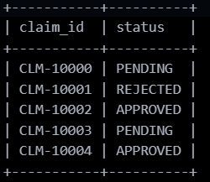
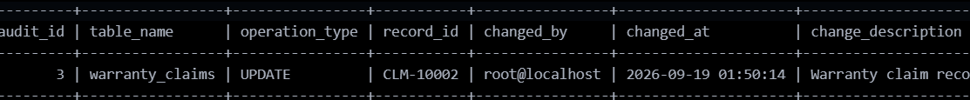

- 10.3 Warranty Trigger Test: An update on the warranty_claims table successfully wrote a corresponding update record to the audit_logs table.
- 10.4 Equipment Trigger Test: An update on the equipment table successfully wrote an update record to the audit_logs table.
- 10.5 Customer Trigger Test: Insert and update operations on the customers table successfully fired both AFTER INSERT and BEFORE UPDATE triggers, logging correctly to audit_logs.

11. Design Decisions & Rationale

11.1 Why Generated Columns Were Used
Generated columns were used because they automatically create readable context from existing relational data. They avoid manual updates because MariaDB calculates the column value whenever the row is queried. This supports RAG preparation because future embedding models need readable text blocks rather than isolated relational columns.
11.2 Why a Stored Procedure Was Used
The stored procedure centralizes the logic for preparing RAG payloads. Instead of manually writing repeated queries, the procedure can be called whenever the RAG-ready output needs to be refreshed.
11.3 Why Triggers Were Used
Triggers were used because audit logging should happen automatically. Users should not have to manually write audit records.
11.4 Why Audit Logs Store JSON
The audit log stores old and new values as JSON because JSON allows multiple column values to be stored clearly in one field. This makes it easier to compare what changed before and after an update.
11.5 Why Security Views Were Used
Security views were used to restrict sensitive information without changing the underlying production tables. The customer view masks phone and email values. The warranty view redacts financial and claim-detail fields.

12. Code Artifacts

The full Milestone 2 SQL file is named: milestone2.sql. The script was executed with: mariadb < milestone2.sql. Code sections successfully generated include Generated Column Code, RAG Payload Table Code, Stored Procedure Code, Audit Log Table Code, Trigger Code, and Security View Code.

13. 4Ds of AI Fluency

Delegation: I used AI assistance to help interpret the Milestone 2 requirements and understand how generated columns, stored procedures, audit triggers, audit logs, and security views fit together. I delegated explanation, troubleshooting, and document organization support to AI while implementing and testing the SQL myself.
Description: I provided the project requirements, my Milestone 1 database structure, my Milestone 2 SQL logic, and MariaDB command output. I described the issues I encountered, such as long RAG output formatting, audit trigger testing, and the equipment payload being placed outside the stored procedure block.
Diligence: I tested the SQL directly in MariaDB. I verified that generated columns existed, the stored procedure created RAG payloads, triggers fired on UPDATE operations, and security views masked or redacted sensitive data. I used VALIDATION QUERIES to confirm results instead of assuming the SQL worked.
Discernment: I reviewed AI suggestions critically and adjusted them to match my actual schema. For example, I identified that the equipment RAG payload logic was accidentally placed outside the stored procedure delimiter block. I corrected the placement so the procedure could include equipment profiles when executed. Final implementation decisions were reviewed and tested by me.

14. Final Summary

Milestone 2 successfully extends the normalized Gigavolt ERP database with SQL programming, RAG preparation, audit logging, and security features.
The database now includes:
- Virtual/generated columns for service, equipment, and warranty context
- A rag_payloads table for AI-ready text
- A stored procedure named sp_Prepare_RAG_Payloads()
- An immutable audit_logs table
- AFTER INSERT and BEFORE UPDATE triggers
- Security views for customer and warranty data
- VALIDATION QUERIES proving that the procedure, triggers, audit logs, and views work
This implementation satisfies the Milestone 2 success criteria because the stored procedure executes and produces RAG-ready output, triggers fire on the required DML operations, audit logs capture change history, and security views restrict sensitive information.

15. Complete Code
USE gigavolt_erp;

-- ============================================================
-- MILESTONE 2: SQL Programming, RAG Payloads, Audit, Security
-- ============================================================

-- ============================================================
-- 1. GENERATED COLUMNS FOR RAG-READY TEXT
-- ============================================================

-- Add generated column to equipment table
ALTER TABLE equipment
ADD COLUMN equipment_context TEXT
GENERATED ALWAYS AS (
CONCAT(
'Equipment ID: ', IFNULL(equipment_id, ''), '. ',
'Model: ', IFNULL(model, ''), '. ',
'Serial Number: ', IFNULL(serial_number, ''), '. ',
'Capacity KW: ', IFNULL(capacity_kw, ''), '. ',
'Voltage: ', IFNULL(voltage, ''), '. ',
'Install Date: ', IFNULL(install_date, ''), '. ',
'Warranty Expiration: ', IFNULL(warranty_expiration, ''), '. ',
'Status: ', IFNULL(status, ''), '. ',
'Location Notes: ', IFNULL(location_notes, ''), '.'
)
) VIRTUAL;

-- Add generated column to dispatches table
ALTER TABLE dispatches
ADD COLUMN service_context TEXT
GENERATED ALWAYS AS (
CONCAT(
'Dispatch ID: ', IFNULL(dispatch_id, ''), '. ',
'Equipment ID: ', IFNULL(equipment_id, ''), '. ',
'Customer ID: ', IFNULL(customer_id, ''), '. ',
'Dispatch Date: ', IFNULL(dispatch_date, ''), '. ',
'Technician: ', IFNULL(technician, ''), '. ',
'Service Type: ', IFNULL(service_type, ''), '. ',
'Hours Spent: ', IFNULL(hours_spent, ''), '. ',
'Labor Cost: ', IFNULL(labor_cost, ''), '. ',
'Resolution Summary: ', IFNULL(resolution_summary, ''), '. ',
'Status: ', IFNULL(status, ''), '.'
)
) VIRTUAL;

-- Add generated column to warranty_claims table
ALTER TABLE warranty_claims
ADD COLUMN warranty_context TEXT
GENERATED ALWAYS AS (
CONCAT(
'Claim ID: ', IFNULL(claim_id, ''), '. ',
'Equipment ID: ', IFNULL(equipment_id, ''), '. ',
'Dispatch ID: ', IFNULL(dispatch_id, ''), '. ',
'Part ID: ', IFNULL(part_id, ''), '. ',
'Claim Date: ', IFNULL(claim_date, ''), '. ',
'Claim Amount: ', IFNULL(claim_amount, ''), '. ',
'Approved Amount: ', IFNULL(approved_amount, ''), '. ',
'Status: ', IFNULL(status, ''), '. ',
'Denial Reason: ', IFNULL(denial_reason, ''), '. ',
'Claim Notes: ', IFNULL(claim_notes, ''), '.'
)
) VIRTUAL;

-- ============================================================
-- 2. CREATE RAG PAYLOAD TABLE
-- ============================================================

DROP TABLE IF EXISTS rag_payloads;

CREATE TABLE rag_payloads (
rag_payload_id INT AUTO_INCREMENT PRIMARY KEY,
source_type VARCHAR(50) NOT NULL,
source_id VARCHAR(50) NOT NULL,
equipment_id VARCHAR(50),
customer_id VARCHAR(50),
rag_text LONGTEXT NOT NULL,
created_at TIMESTAMP DEFAULT CURRENT_TIMESTAMP
) ENGINE=InnoDB;

-- ============================================================
-- 3. STORED PROCEDURE TO PREPARE RAG PAYLOADS
-- ============================================================

DELIMITER //

DROP PROCEDURE IF EXISTS sp_Prepare_RAG_Payloads //

CREATE PROCEDURE sp_Prepare_RAG_Payloads()
BEGIN
-- Clear previous RAG payloads so the procedure can be rerun
TRUNCATE TABLE rag_payloads;

-- Create RAG payloads from dispatch/service records
INSERT INTO rag_payloads (
source_type,
source_id,
equipment_id,
customer_id,
rag_text
)
SELECT
'DISPATCH_SERVICE_LOG' AS source_type,
d.dispatch_id AS source_id,
d.equipment_id,
d.customer_id,
TRIM(
REGEXP_REPLACE(
CONCAT(
'Service Record. ',
'Dispatch ID: ', IFNULL(d.dispatch_id, ''), '. ',
'Dispatch Date: ', IFNULL(d.dispatch_date, ''), '. ',
'Technician: ', IFNULL(d.technician, ''), '. ',
'Service Type: ', IFNULL(d.service_type, ''), '. ',
'Status: ', IFNULL(d.status, ''), '. ',
'Resolution: ', IFNULL(d.resolution_summary, ''), '. ',
'Equipment Model: ', IFNULL(e.model, ''), '. ',
'Serial Number: ', IFNULL(e.serial_number, ''), '. ',
'Equipment Status: ', IFNULL(e.status, ''), '. ',
'Location Notes: ', IFNULL(e.location_notes, ''), '. ',
'Customer Company: ', IFNULL(c.company_name, ''), '. '
),
'<[^>]+>',
''
)
) AS rag_text
FROM dispatches d
LEFT JOIN equipment e
ON d.equipment_id = e.equipment_id
LEFT JOIN customers c
ON d.customer_id = c.customer_id;

-- Create RAG payloads from warranty claims
INSERT INTO rag_payloads (
source_type,
source_id,
equipment_id,
customer_id,
rag_text
)
SELECT
'WARRANTY_CLAIM' AS source_type,
wc.claim_id AS source_id,
wc.equipment_id,
e.customer_id,
TRIM(
REGEXP_REPLACE(
CONCAT(
'Warranty Claim. ',
'Claim ID: ', IFNULL(wc.claim_id, ''), '. ',
'Claim Date: ', IFNULL(wc.claim_date, ''), '. ',
'Claim Amount: ', IFNULL(wc.claim_amount, ''), '. ',
'Approved Amount: ', IFNULL(wc.approved_amount, ''), '. ',
'Claim Status: ', IFNULL(wc.status, ''), '. ',
'Denial Reason: ', IFNULL(wc.denial_reason, ''), '. ',
'Claim Notes: ', IFNULL(wc.claim_notes, ''), '. ',
'Equipment Model: ', IFNULL(e.model, ''), '. ',
'Serial Number: ', IFNULL(e.serial_number, ''), '. ',
'Part Name: ', IFNULL(p.part_name, ''), '. ',
'Part Category: ', IFNULL(p.category, ''), '. ',
'Manufacturer: ', IFNULL(p.manufacturer, ''), '. '
),
'<[^>]+>',
''
)
) AS rag_text
FROM warranty_claims wc
LEFT JOIN equipment e
ON wc.equipment_id = e.equipment_id
LEFT JOIN parts p
ON wc.part_id = p.part_id;

-- Create RAG payloads from equipment records
INSERT INTO rag_payloads (
source_type,
source_id,
equipment_id,
customer_id,
rag_text
)
SELECT
'EQUIPMENT_PROFILE' AS source_type,
e.equipment_id AS source_id,
e.equipment_id,
e.customer_id,
TRIM(
REGEXP_REPLACE(
REGEXP_REPLACE(
CONCAT(
'Equipment Profile. ',
'Equipment ID: ', IFNULL(e.equipment_id, ''), '. ',
'Customer ID: ', IFNULL(e.customer_id, ''), '. ',
'Customer Company: ', IFNULL(c.company_name, ''), '. ',
'Model: ', IFNULL(e.model, ''), '. ',
'Serial Number: ', IFNULL(e.serial_number, ''), '. ',
'Install Date: ', IFNULL(e.install_date, ''), '. ',
'Capacity KW: ', IFNULL(e.capacity_kw, ''), '. ',
'Voltage: ', IFNULL(e.voltage, ''), '. ',
'Warranty Expiration: ', IFNULL(e.warranty_expiration, ''), '. ',
'Equipment Status: ', IFNULL(e.status, ''), '. ',
'Location Notes: ', IFNULL(e.location_notes, ''), '. '
),
'<[^>]+>',
''
),
'[[:space:]]+',
' '
)
) AS rag_text
FROM equipment e
LEFT JOIN customers c
ON e.customer_id = c.customer_id;

END //

DELIMITER ;

-- ============================================================
-- 4. AUDIT LOG TABLE
-- ============================================================

DROP TABLE IF EXISTS audit_logs;

CREATE TABLE audit_logs (
audit_id BIGINT AUTO_INCREMENT PRIMARY KEY,
table_name VARCHAR(100) NOT NULL,
operation_type VARCHAR(20) NOT NULL,
record_id VARCHAR(100) NOT NULL,
old_values LONGTEXT,
new_values LONGTEXT,
changed_by VARCHAR(100) DEFAULT CURRENT_USER(),
changed_at TIMESTAMP DEFAULT CURRENT_TIMESTAMP,
change_description VARCHAR(255)
) ENGINE=InnoDB;

-- ============================================================
-- 5. MAKE AUDIT LOG IMMUTABLE
-- Prevent users from updating or deleting audit records
-- ============================================================

DELIMITER //

DROP TRIGGER IF EXISTS trg_audit_logs_no_update //

CREATE TRIGGER trg_audit_logs_no_update
BEFORE UPDATE ON audit_logs
FOR EACH ROW
BEGIN
SIGNAL SQLSTATE '45000'
SET MESSAGE_TEXT = 'Audit logs are immutable and cannot be updated.';
END //

DROP TRIGGER IF EXISTS trg_audit_logs_no_delete //

CREATE TRIGGER trg_audit_logs_no_delete
BEFORE DELETE ON audit_logs
FOR EACH ROW
BEGIN
SIGNAL SQLSTATE '45000'
SET MESSAGE_TEXT = 'Audit logs are immutable and cannot be deleted.';
END //

DELIMITER ;

-- ============================================================
-- 6. AUDIT TRIGGERS FOR CUSTOMERS
-- ============================================================

DELIMITER //

DROP TRIGGER IF EXISTS trg_customers_after_insert //

CREATE TRIGGER trg_customers_after_insert
AFTER INSERT ON customers
FOR EACH ROW
BEGIN
INSERT INTO audit_logs (
table_name,
operation_type,
record_id,
old_values,
new_values,
change_description
)
VALUES (
'customers',
'INSERT',
NEW.customer_id,
NULL,
JSON_OBJECT(
'customer_id', NEW.customer_id,
'company_name', NEW.company_name,
'contact_name', NEW.contact_name,
'phone', NEW.phone,
'email', NEW.email,
'address', NEW.address,
'zip', NEW.zip,
'created_date', NEW.created_date,
'status', NEW.status
),
'New customer record created'
);
END //

DROP TRIGGER IF EXISTS trg_customers_before_update //

CREATE TRIGGER trg_customers_before_update
BEFORE UPDATE ON customers
FOR EACH ROW
BEGIN
INSERT INTO audit_logs (
table_name,
operation_type,
record_id,
old_values,
new_values,
change_description
)
VALUES (
'customers',
'UPDATE',
OLD.customer_id,
JSON_OBJECT(
'customer_id', OLD.customer_id,
'company_name', OLD.company_name,
'contact_name', OLD.contact_name,
'phone', OLD.phone,
'email', OLD.email,
'address', OLD.address,
'zip', OLD.zip,
'created_date', OLD.created_date,
'status', OLD.status
),
JSON_OBJECT(
'customer_id', NEW.customer_id,
'company_name', NEW.company_name,
'contact_name', NEW.contact_name,
'phone', NEW.phone,
'email', NEW.email,
'address', NEW.address,
'zip', NEW.zip,
'created_date', NEW.created_date,
'status', NEW.status
),
'Customer record updated'
);
END //

DELIMITER ;

-- ============================================================
-- AUDIT TRIGGERS FOR WARRANTY CLAIMS
-- ============================================================

DELIMITER //

DROP TRIGGER IF EXISTS trg_warranty_claims_after_insert //

CREATE TRIGGER trg_warranty_claims_after_insert
AFTER INSERT ON warranty_claims
FOR EACH ROW
BEGIN
INSERT INTO audit_logs (
table_name,
operation_type,
record_id,
old_values,
new_values,
change_description
)
VALUES (
'warranty_claims',
'INSERT',
NEW.claim_id,
NULL,
JSON_OBJECT(
'claim_id', NEW.claim_id,
'equipment_id', NEW.equipment_id,
'dispatch_id', NEW.dispatch_id,
'part_id', NEW.part_id,
'claim_date', NEW.claim_date,
'claim_amount', NEW.claim_amount,
'approved_amount', NEW.approved_amount,
'status', NEW.status,
'denial_reason', NEW.denial_reason,
'claim_notes', NEW.claim_notes
),
'New warranty claim record created'
);
END //

DROP TRIGGER IF EXISTS trg_warranty_claims_before_update //

CREATE TRIGGER trg_warranty_claims_before_update
BEFORE UPDATE ON warranty_claims
FOR EACH ROW
BEGIN
INSERT INTO audit_logs (
table_name,
operation_type,
record_id,
old_values,
new_values,
change_description
)
VALUES (
'warranty_claims',
'UPDATE',
OLD.claim_id,
JSON_OBJECT(
'claim_id', OLD.claim_id,
'equipment_id', OLD.equipment_id,
'dispatch_id', OLD.dispatch_id,
'part_id', OLD.part_id,
'claim_date', OLD.claim_date,
'claim_amount', OLD.claim_amount,
'approved_amount', OLD.approved_amount,
'status', OLD.status,
'denial_reason', OLD.denial_reason,
'claim_notes', OLD.claim_notes
),
JSON_OBJECT(
'claim_id', NEW.claim_id,
'equipment_id', NEW.equipment_id,
'dispatch_id', NEW.dispatch_id,
'part_id', NEW.part_id,
'claim_date', NEW.claim_date,
'claim_amount', NEW.claim_amount,
'approved_amount', NEW.approved_amount,
'status', NEW.status,
'denial_reason', NEW.denial_reason,
'claim_notes', NEW.claim_notes
),
'Warranty claim record updated'
);
END //

DELIMITER ;

-- ============================================================
-- 7. AUDIT TRIGGERS FOR EQUIPMENT
-- ============================================================

DELIMITER //

DROP TRIGGER IF EXISTS trg_equipment_after_insert //

CREATE TRIGGER trg_equipment_after_insert
AFTER INSERT ON equipment
FOR EACH ROW
BEGIN
INSERT INTO audit_logs (
table_name,
operation_type,
record_id,
old_values,
new_values,
change_description
)
VALUES (
'equipment',
'INSERT',
NEW.equipment_id,
NULL,
JSON_OBJECT(
'equipment_id', NEW.equipment_id,
'customer_id', NEW.customer_id,
'model', NEW.model,
'serial_number', NEW.serial_number,
'install_date', NEW.install_date,
'capacity_kw', NEW.capacity_kw,
'voltage', NEW.voltage,
'warranty_expiration', NEW.warranty_expiration,
'status', NEW.status,
'location_notes', NEW.location_notes
),
'New equipment record created'
);
END //

DROP TRIGGER IF EXISTS trg_equipment_before_update //

CREATE TRIGGER trg_equipment_before_update
BEFORE UPDATE ON equipment
FOR EACH ROW
BEGIN
INSERT INTO audit_logs (
table_name,
operation_type,
record_id,
old_values,
new_values,
change_description
)
VALUES (
'equipment',
'UPDATE',
OLD.equipment_id,
JSON_OBJECT(
'equipment_id', OLD.equipment_id,
'customer_id', OLD.customer_id,
'model', OLD.model,
'serial_number', OLD.serial_number,
'install_date', OLD.install_date,
'capacity_kw', OLD.capacity_kw,
'voltage', OLD.voltage,
'warranty_expiration', OLD.warranty_expiration,
'status', OLD.status,
'location_notes', OLD.location_notes
),
JSON_OBJECT(
'equipment_id', NEW.equipment_id,
'customer_id', NEW.customer_id,
'model', NEW.model,
'serial_number', NEW.serial_number,
'install_date', NEW.install_date,
'capacity_kw', NEW.capacity_kw,
'voltage', NEW.voltage,
'warranty_expiration', NEW.warranty_expiration,
'status', NEW.status,
'location_notes', NEW.location_notes
),
'Equipment record updated'
);
END //

DELIMITER ;

-- ============================================================
-- 8. AUDIT TRIGGERS FOR DISPATCHES / SERVICE LOGS
-- ============================================================

DELIMITER //

DROP TRIGGER IF EXISTS trg_dispatches_after_insert //

CREATE TRIGGER trg_dispatches_after_insert
AFTER INSERT ON dispatches
FOR EACH ROW
BEGIN
INSERT INTO audit_logs (
table_name,
operation_type,
record_id,
old_values,
new_values,
change_description
)
VALUES (
'dispatches',
'INSERT',
NEW.dispatch_id,
NULL,
JSON_OBJECT(
'dispatch_id', NEW.dispatch_id,
'equipment_id', NEW.equipment_id,
'customer_id', NEW.customer_id,
'dispatch_date', NEW.dispatch_date,
'technician', NEW.technician,
'service_type', NEW.service_type,
'hours_spent', NEW.hours_spent,
'labor_cost', NEW.labor_cost,
'resolution_summary', NEW.resolution_summary,
'status', NEW.status
),
'New dispatch/service record created'
);
END //

DROP TRIGGER IF EXISTS trg_dispatches_before_update //

CREATE TRIGGER trg_dispatches_before_update
BEFORE UPDATE ON dispatches
FOR EACH ROW
BEGIN
INSERT INTO audit_logs (
table_name,
operation_type,
record_id,
old_values,
new_values,
change_description
)
VALUES (
'dispatches',
'UPDATE',
OLD.dispatch_id,
JSON_OBJECT(
'dispatch_id', OLD.dispatch_id,
'equipment_id', OLD.equipment_id,
'customer_id', OLD.customer_id,
'dispatch_date', OLD.dispatch_date,
'technician', OLD.technician,
'service_type', OLD.service_type,
'hours_spent', OLD.hours_spent,
'labor_cost', OLD.labor_cost,
'resolution_summary', OLD.resolution_summary,
'status', OLD.status
),
JSON_OBJECT(
'dispatch_id', NEW.dispatch_id,
'equipment_id', NEW.equipment_id,
'customer_id', NEW.customer_id,
'dispatch_date', NEW.dispatch_date,
'technician', NEW.technician,
'service_type', NEW.service_type,
'hours_spent', NEW.hours_spent,
'labor_cost', NEW.labor_cost,
'resolution_summary', NEW.resolution_summary,
'status', NEW.status
),
'Dispatch/service record updated'
);
END //

DELIMITER ;

-- ============================================================
-- 9. SECURITY VIEWS
-- Hide sensitive customer phone, email, and address
-- ============================================================

DROP VIEW IF EXISTS vw_customer_safe;

CREATE VIEW vw_customer_safe AS
SELECT
c.customer_id,
c.company_name,
c.contact_name,
CONCAT('***-***-', RIGHT(c.phone, 4)) AS masked_phone,
CONCAT(
LEFT(c.email, 2),
'***@',
SUBSTRING_INDEX(c.email, '@', -1)
) AS masked_email,
c.zip,
l.city,
l.state,
l.country,
c.created_date,
c.status
FROM customers c
LEFT JOIN locations l
ON c.zip = l.zip;

DROP VIEW IF EXISTS vw_rag_service_context;

CREATE VIEW vw_rag_service_context AS
SELECT
d.dispatch_id,
d.equipment_id,
d.customer_id,
e.model,
e.serial_number,
d.dispatch_date,
d.technician,
d.service_type,
d.status,
CONCAT(
e.equipment_context,
' ',
d.service_context
) AS full_service_context
FROM dispatches d
LEFT JOIN equipment e
ON d.equipment_id = e.equipment_id;

-- ============================================================
-- SECURITY VIEW FOR WARRANTY CLAIMS
-- ============================================================

DROP VIEW IF EXISTS vw_warranty_claims_safe;

CREATE VIEW vw_warranty_claims_safe AS
SELECT
wc.claim_id,
wc.equipment_id,
wc.dispatch_id,
wc.part_id,
wc.claim_date,

-- Mask financial details for non-privileged users
CASE
WHEN wc.claim_amount IS NULL THEN NULL
ELSE 'REDACTED'
END AS claim_amount_masked,

CASE
WHEN wc.approved_amount IS NULL THEN NULL
ELSE 'REDACTED'
END AS approved_amount_masked,

wc.status,

-- Hide detailed denial reason and claim notes
CASE
WHEN wc.denial_reason IS NULL OR wc.denial_reason = '' THEN 'Not provided'
ELSE 'Restricted'
END AS denial_reason_summary,

CASE
WHEN wc.claim_notes IS NULL OR wc.claim_notes = '' THEN 'No claim notes'
ELSE 'Restricted'
END AS claim_notes_summary,

e.model AS equipment_model,
e.serial_number,
e.status AS equipment_status
FROM warranty_claims wc
LEFT JOIN equipment e
ON wc.equipment_id = e.equipment_id;

-- Optional restricted analyst user example
-- Change the password before using in a real environment

DROP USER IF EXISTS 'gigavolt_analyst'@'%';

CREATE USER 'gigavolt_analyst'@'%' IDENTIFIED BY 'ChangeThisPassword123!';

GRANT SELECT ON gigavolt_erp.vw_customer_safe TO 'gigavolt_analyst'@'%';
GRANT SELECT ON gigavolt_erp.vw_rag_service_context TO 'gigavolt_analyst'@'%';
GRANT SELECT ON gigavolt_erp.rag_payloads TO 'gigavolt_analyst'@'%';
GRANT SELECT ON gigavolt_erp.vw_warranty_claims_safe TO 'gigavolt_analyst'@'%';
-- Do NOT grant direct SELECT on customers to this user.
-- This proves sensitive customer data is protected.

FLUSH PRIVILEGES;

~ Thank You ~

